
FIRST TERM EXAMINATION (2021-22)
SET-1
Subject: GEOGRAPHY  Grade: 12 |  |  | Max. Marks:35  Time: 90 mins
Name: |  |  |  |  |  | Section: | Roll No:
General Instructions:
- GENERAL INSTRUCTIONS
- 1. The Question Paper contains three sections (A, B & C).
- 2. Section A has 24 questions. Attempt any 20 questions.
- 3. Section B has 24 questions. Attempt any 20 questions (Map Section (Q.No. 25-29) is mandatory to attempt).
- 4. Section C has 12 questions. Attempt any 10 questions. (First Part of C Section (Source based has 4 questions (Q.No. 49-52) and all need to be attempted).
- 5. All questions carry equal marks.
- 6. There is no negative marking.
SECTION A
There are 24 questions in this section.
Attempt any 20 questions.
 | The period from 1901 to 1921 is referred to as period of:
 | a. | stagnant or stationary phase of growth of India’s population |  | b. |  | steady population growth.
 | c. | population explosion in India. |  | d. |  | None of the Above
. Arrange the following phases in a sequence order according to their occurrence in Indian population:
(i) Population explosion
(ii) Stationary phase
(iii) Decreased growth
(iv) Steady growth
 | a. | i, iv, ii, iii |  | b. |  | iv, i, iii, ii
 | c. | ii, iv, i, iii |  | d. |  | iii, ii, iv, i
 | A continuous belt of states from west to east in the north-west, north, and north central parts of the country has relatively _________growth rate than the southern states
 | a. | high |  | b |  | low
 | c. | slow |  | d |  | fast
 | The interaction between primitive human society and strong forces of nature is termed as:
 | a. | environmental determinism |  | b |  | neo- determinism
 | c. | bio- determinism |  | d |  | anti-determinism
- . | Arrange the following approaches in a sequential order according to their development. Choose the correct option.  1. Spatial organization  2. Regional approach  3. Areal differentiation  4. Humanistic approach
 | a. | 1 4 2 3 |  | b |  | 4 1 3 2
 | c. | 2 3 1 4 |  | d |  | 3 2 4 1
 | If the population decreases between two points of time, it is known as:
 | a. | neutral growth of population |  | b |  | positive growth of population
 | c. | negligible growth of population |  | d |  | negative growth of population
 | Which continent has the highest growth rate of population
 | a. | America |  | b |  | Africa
 | c. | Australia |  | d |  | Asia
 | Which of the following factor helped in the reduction of birth rate and provided a stage for accelerated population growth?
 | a. | Technological advancement |  | b |  | Conflicts and wars
 | c. | Emergence of world power |  | d |  | Introduction of birth control policies
Arrange the four stages of demographic transition in the correct order:
(i) Pre- industrial stage
(ii) Urbanizing/industrializing
(iii) Mature industrial
(iv) Post-industrial
 | a. | (i),(ii),(iii),(iv) |  | b |  | iv),(ii),(iii),(i)
 | c. | (iii),(iv),(i),(ii) |  | d |  | (ii),(i),(iii),(iv)
 | .Nainital, Mussoorie, Shimla, Pachmarhi, Jodhpur are :
 | a. | transport towns |  | b |  | tourist towns
 | c. | industrial towns |  | d |  | educational towns
Arrange the following agglomeration in the sequence of their ranks i.e., 1st, 2nd, 3rd and 4th.
(i) Delhi
(ii) Chennai
(iii) Greater Mumbai
(iv) Kolkata
 | a. | ii, i, iv, iii |  | b |  | i, ii, iii, iv
 | c. | iv, ii, i, iii |  | d |  | iii, iv, i, ii
 | Which one of the following south Indian states has the highest groundwater utilisation (in per cent) of its total ground water potential?
 | a. | Tamil Nadu |  | b |  | Andhra Pradesh
 | c. | Kerala |  | d |  | Karnataka
 | The highest proportion of the total water used in the India is in which one of the following sectors?
 | a. | Irrigation |  | b |  | Domestic use
 | c. | Industries |  | d |  | None of the above
Study the given graph showing causes of migration of male population in India carefully and answer the following questions:
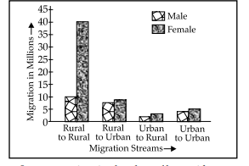
Intra state migration by place of last residence indicating migration steams (Duration 0-9 year)
Which migration stream shows the highest number of migration both male and female categories?
 | a. | Rural to Urban |  | b |  | Urban to Rural
 | c. | Rural to Rural |  | d |  | Urban to Urban
 | ____________was the state, has the largest number of net out-migrants from the state
 | a. | Uttar Pradesh and West Bengal |  | b |  | Uttar Pradesh and Bihar
 | c. | Delhi and Chennai |  | d |  | Mumbai and Gujarat
 | Over withdrawal of ground water in some states like ___________ and ____________ has increased fluoride concentration in ground water.
 | a. | Punjab and Haryana |  | b |  | Rajasthan and Maharashtra
 | c. | Bihar and Uttar Pradesh |  | d. |  | Gujarat and Karnataka
 | The success of watershed development largely depends upon ___________ participation.
 | a. | government |  | b |  | labourers
 | c. | villagers |  | d |  | community
 | Name the board that monitors the water quality of national aquatic resources
 | a. | The Central Pollution Centre Board |  | b |  | The Central Pollution Communication Board
 | c. | The Central Pollution Control Board |  | d |  | The Central Pollution Common Board
 | Which one of the following is the main feature of rural settlement?
 | a. | Derive economic needs from primary activities |  | b |  | Derive economic needs from secondary activities
 | c. | Derive economic needs from tertiary activities |  | d |  | Derive economic needs from quaternary activities
Assertion (A): Settlements vary in size and type.
Reason(R): They range from a hamlet to metropolitan cities
Directions : In the following questions, A statement of Assertion (A) is followed by a statement of Reason (R). Mark the correct choice as:
 | a. | Both A and R are true, and R is the correct explanation of A |  | b |  | Both A and R are true but R is NOT the correct explanation of A
 | c. | A is true but R is false |  | d |  | A is false and R is true
 | Cities having more than 5 million population are known as :
 | a. | hyper city |  |  |  | Metropolitan city
 | c. | mega city |  |  |  | super city
 | Countries with high human development index are those which have a score of:
 | a. | about 0.8 |  | b |  | below 0.8
 | c. | over 0.8 |  | d |  | not even close to 0.8
 | ____________ measures the shortfall in human development
 | a. | Poverty index |  | b |  | Human development index
 | c. | GDP |  | d |  | Happiness Index
24 | Overhead costs such as safety precautions and equipment are relatively low in:
 | a. | Underground mining |  | b |  | Digging down mining
 | c. | Underwater mining |  | d |  | Open cast mining
SECTION B
(There are 24 questions in this section. Attempt any 20 questions.)
Question no. 25-29 are based on map and are mandatory to attempt.

 | 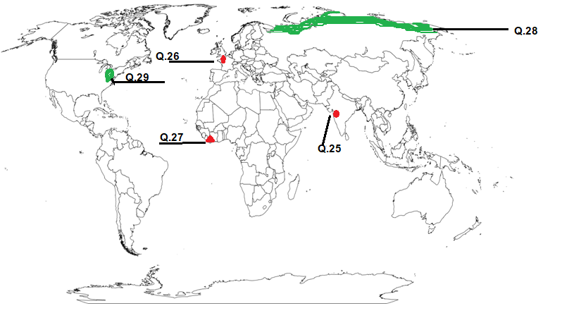
25 | Choose the largest urban agglomeration city in India .
 | a. | Cochin |  | b. |  | Greater Mumbai
 | c. | Chennai |  | d. |  | Surat
26 | Which is the largest country in Europe?
 | a. | France |  | b. |  | Denmark
 | c. | Germany |  | d. |  | Spain
27 | the country with high population growth rate (%) 1995-2000
 | a. | Yemen |  | b. |  | Oman
 | c. | Liberia |  | d. |  | Denmark
28 | Identify the core region where pastoral nomadic herding takes place
 | a. | Northern China |  | b. |  | Tundra region of Eurasia
 | c. | Northern region of Alaska |  | d. |  | Northern Europe
29 | Identify the region of mixed farming
 | a. | Eastern North America |  | b. |  | Northern Canada
 | c. | South Central Canada |  | d. |  | American
 | Question no. 30-48 (Attempt any 15)
30 | 1): Death rate plays an active role in population change.  2): Population growth occurs not only by increasing births rate but also due to decreasing death rate
 | a. | Only 1 is correct |  | b. |  | Only 2 is correct
 | c. | Both the statements are incorrect |  | d. |  | Both statements are correct and statement 2 correctly explains the statement
31 | Development means:
 | a. | a qualitative change which is always value positive |  | b. |  | a qualitative change which is always value negative.
 | c. | a quantitative change which is always value positive |  | d. |  | All of the Above
32 | Why products of gathering cannot compete in the world market?
 | a. | Close market concept |  | b. |  | Availability of less price synthetic products
 | c. | Use of old technology |  | d. |  | None of the Above
33 | Which one from the following sentences is wrong? During the colonial period-
 | a. | Indentured labour from Uttar Pradesh and Bihar were sent to Mauritius, Caribbean islands by French |  | b. |  | Indentured labour from Goa, Daman and Diu were sent to Angola, Mozambique by Portuguese.
 | c. | Indentured labour were sent to Reunion island and Martinique by French |  | d. |  | All such migrations were covered under the time-bound contract known as Girmit Act
34 | A continuous urban spread constituting a town and its adjoining outgrowths is known as :
 | a. | Urban growth |  | b. |  | Urban agglomeration
 | c. | Urban outgrowth |  | d. |  | Urban spread
35 | The use of minerals in ancient times was largely confined to the making of:
 | a. | Tools |  | b. |  | utensils
 | c. | weapons |  | d. |  | All of the Above
36 | Assertion (A): Water gets polluted by foreign matters, such as micro-organisms, chemicals, industrial and other wastes  Reason (R): The Ganga and the Yamuna are the two highly clean rivers in the country
 | a. | Both A and R are true and R is the correct explanation of A |  | b. |  | Both A and R are true but R is NOT the correct explanation of A
 | c. | A is true but R is false. |  | d. |  | A is false and R is true.
37 | __________ can be defined as a process that extracts minerals from saline water
 | a. | Salination |  | b. |  | Desalination
 | c. | Detoxication |  | d. |  | Saturation
38 | What is called the mother of all branches of knowledge?
 | a. | Sociology |  | b. |  | Geography
 | c. | History |  | d. |  | Psychology
39 | Arrange the countries in ascending order of their population:  (i) China  (ii) USA (  iii) India  (iv) Indonesia
 | a. | (i),(ii),(iii),(iv) |  | b. |  | (iv),(ii),(iii),(i)
 | c. | (iii),(iv),(i),(ii) |  | d. |  | iv),(iii),(ii),(i)
40 | The concept of human development was introduced by:
 | a. | Dr. Mahbub-ul-Haq |  | b. |  | Nelson Mandela
 | c. | Mao Zedong |  | d. |  | Winston Churchill
41 | ______________ is the term which means the spread of people a cross the world
 | a. | Population disturbance |  | b. |  | Population distribution
 | c. | Population counting |  | d. |  | None of the above
42 | The state of India which has the lowest percentage of population below poverty line:
 | a. | Punjab |  | b. |  | TamilNadu
 | c. | Jammu&Kashmir |  | d. |  | Goa
43 | Which one from the following is not characteristic of Cooperative farming?
 | a. | Introduced in many western European countries such as Denmark and Netherland |  | b. |  | Government fixes target to the crop and purchase it on pre-defined price.
 | c. | Products are available at cheaper rates |  | d. |  | Co-operative societies help farmers
44 | There is no Off Season in which from the following farming?
 | a. | Mediterranean agriculture |  | b. |  | Plantation agriculture
 | c. | Extensive Commercial grain farming |  | d. |  | Dairy farming
45 | Which of the one is not a Pillar of human development?
 | a. | Equity |  | b. |  | Capacity
 | c. | Sustainability |  | d. |  | Productivity
46 | Which country have introduced the Gross National Happiness index first?
 | a. | Nepal |  | b. |  | Bhutan
 | c. | Bangladesh |  | d. |  | Pakistan
47 | Which is not a fact?
 | a. | Pollution is caused due to industrial development |  | b. |  | Global warming is due to greenhouse effect
 | c. | Ozone layer is depleted due to primitive agriculture |  | d. |  | Land has been degraded due to pollution
48 | In which of the following streams of migration ,females predominate in both intra-state and Inter-state migration?
 | a | Urban to urban |  | b |  | Urban to rural
 | c | Rural to rural |  | d |  | Urban to urban
SECTION C
SOURCE BASED QUESTIONS
Question number 49 to 52 are compulsory to attempt:
. Read the case study given below and answer the questions that follow:
The concept of human development was introduced by Dr. Mahbub-ul-Haq. Dr Haq has described human development as development that enlarges people’s choices and improves their lives. People are central to all development under this concept. These choices are not fixed but keep on changing. The basic goal of development is to create conditions where people can live meaningful lives. A meaningful life is not just a long one. It must be a life with some purpose. This means that people must be healthy, be able to develop their talents, participate in society and be free to achieve their goals

49 | According to Dr. Haq’s concept of human development, who is central to all development?
 | a.  c. | Countries |  |  | b. Continents
 | a.  c. | People |  |  | d. Policies
50 | How does HDI help the United Nations?
 | a. | Helps to determine which country needs assistance |  | b. |  | Helps to determine which country is economical strong
 | c. | Helps to determine which country has dictatorship |  | d. |  | None of the Above
51 | Why is Human Development information important?
 | a. | Measure’s the progress made in terms of government policies |  | b. |  | Measure’s development of a country
 | c. | Measure’s birth and death rate |  | d. |  | Measure countries import and export
52 | State one important means to Human Development rather an end in itself?
 | a. | Income growth |  | b. |  | Migration
 | c. | Emigration |  | d. |  | Birth rate
GRAPH BASED QUESTION
Attempt any 3 questions from the following questions 53-56
Study the given graph carefully and answer the following questions :
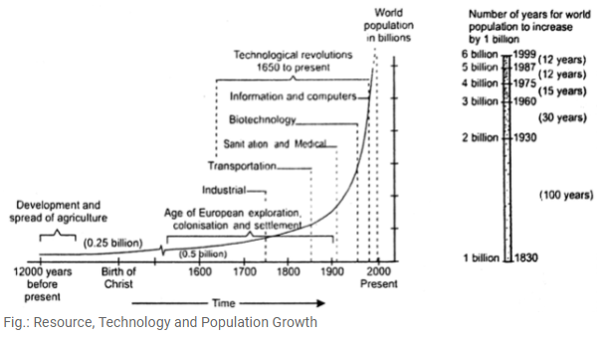
53 | Which of these periods closely represents the European explorations?
 | a. | 1 CE to 1600 CE |  | b. |  | 1500 CE to 1700 CE
 | c. | 1520 CE to 1900 CE |  | d. |  | 1650 CE to 1950 CE
54 | In how many years did world population increase from 4 billion to 5 billion?
 | a. | 12 years |  | b. |  | 15 years
 | c. | 30 years |  | d. |  | 50 years
55 | What is the speciality of the period 1650 CE to present?
 | a. | Development and spread of agriculture |  | b. |  | Colonialization
 | c. | Technological revolutions |  | d. |  | Transportation
56 | What was the approximate population of the world in 1600s?
 | a. | 0.25 billion |  | b. |  | 0.5 billion
 | c. | 0.75 billion |  | d. |  | 1 billion
DATA BASED QUESTIONS
Attempt any 3 questions from the following questions 57-60.
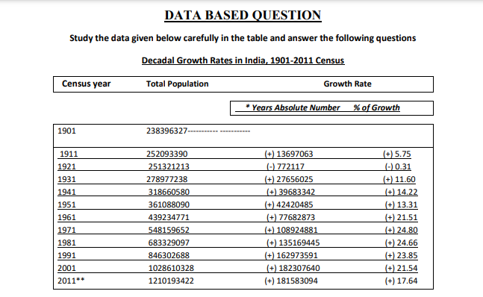

57. | Which decade Shows minus growth rate?
 | a. | 1911-1921 |  | b. |  | 1921-1931
 | c. | )1931-1941 |  | d. |  | 1941-1951
58. | What is the main reasons for the decline in the population of this decade?
 | a. | high mortality and low birth rate |  | b |  | low mortality and high birth rate
 | c. | high mortality and high birth rate |  | d |  | low mortality and low birth rate
59. | Which decades are referred to as the period of steady population growth?
 | a. | 1901-1941 |  | b |  | 1921-1951
 | c | 1951-2001 |  | d |  | 1971-1991
60. | Why has the population growth decline in the last two decades?
 | a. | Decline Birth rate |  | b |  | Improvement of Literacy rate
 | c | Awareness |  | d |  | All of the above

